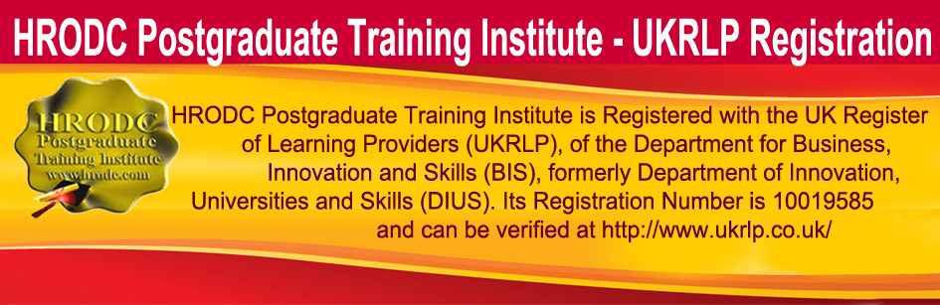
Registration for
Free ‘Organisational Improvement: Revitalizing Organisations, Through Organisational (Organizational) Development and Change (Part 1) Seminar’
Dubai, UAE
Participants will be Awarded A Certificate of Attendance and Participation in ‘Organisational Improvement: Revitalizing Organisations, Through Organisational (Organizational) Development and Change (Part 1)’
Thursday December 10, 2015; 13:00 – 17:00 (1-5 pm.)
Venue To Be Advised Shortly
To be completed by, or on behalf of, the Attendee.

General Information

Name of Participant:
Gender (Male/Female):
Nationality:
Position Held:
Name of Organisation:
Address of Organisation:
Telephone Number:
Mobile Number:
E-mail Address:

On completion of the form, please send it to fria@hrodc.com or fria.hrodc@outlook.com

Please Affix Your Picture Here,
For Your Seminar ID

